Reco-Do
Problem Statement and Solution Overview
Capstone project · AICA Level 2 · October 2026

1. Summary
Reconciliation, proving that two records of the same activity agree, is one of the most frequent and time-consuming tasks in accounting. It is also one of the most manual: most finance teams still reconcile bank statements, customer and supplier accounts, intercompany balances and payroll by copying data into Excel and matching lines by hand.
Reco-Do is a Windows desktop application that does the routine matching automatically, explains every match in plain English, highlights only the items that need a human decision, and produces a finished reconciliation workbook with a full audit trail. Artificial intelligence is available as an optional assistant for the hardest leftover items, but it never makes a decision on its own, and no data leaves the computer unless the user explicitly approves it.

2. The problem

2.1 Who is affected
Accountants, finance executives and controllers in small and mid-sized businesses, accounting and audit firms, and shared-service teams. These users reconcile several accounts every month-end, and some accounts daily, usually without access to an expensive enterprise reconciliation system.

2.2 How reconciliations are done today
A typical bank reconciliation looks like this: download the bank statement (often as a PDF), re-key or convert it into Excel, export the general-ledger cash account, then match the two lists line by line with filters, VLOOKUP formulas and colour highlighting. Whatever is left is typed into a reconciliation statement. The same pattern repeats for customer statements (AR), supplier statements (AP), intercompany accounts and payroll.

2.3 Why this is hard
- Inconsistent file formats. Bank statements arrive as PDFs or as Excel files with logos and address lines above the real header. Amounts may be in one signed column, in separate Debit and Credit columns, or with a Dr/Cr indicator.
- Opposite sign conventions. A credit on the bank statement is a debit in the company’s cash ledger; a customer’s statement is the mirror image of our receivables ledger. Simple formulas miss these.
- Near-matches, not exact matches. The same transaction appears with a different date (value date vs posting date), a reference written differently (“FT2609ABC” vs “Rcpt FT2609ABC Al Noor”), or an amount with a typing error (8,450 vs 8,540).
- One-to-many items. One bank receipt may settle three invoices; two bank lines may correspond to one ledger entry. Lookup formulas cannot find these combinations.
- Duplicates. Several identical amounts on the same day make it easy to match the wrong pair.
- No audit trail. Spreadsheet reconciliations rarely record who matched what, when and why, which makes review and audit slow.
- Data privacy. Many online tools require uploading bank and customer data to a third-party server, which is often not acceptable to the business or its auditors.
- Supporting chores. Converting PDFs to Excel, merging monthly statements, splitting PDFs and cleaning messy exports add more manual work around every reconciliation.

2.4 The cost
The result is hours of repetitive work each month-end, a real risk of errors and missed items, reconciliations that are hard to review, and late closing of the books. Skilled accountants spend their time on mechanical matching instead of investigating the genuine differences.

2.5 Problem statement
Accounting professionals need a simple, affordable and private way to reconcile any two sets of financial records quickly and accurately. It must handle real-world file formats and near-matches, explain its results, keep an audit trail, and use AI only as a controlled assistant, never as an unchecked decision-maker.

3. Objectives
- Reduce manual matching time by automatically reconciling the clear-cut items.
- Make every match explainable and every decision traceable.
- Handle real-world files: junk header rows, PDF statements, different amount layouts and sign conventions.
- Support the common reconciliations (bank, receivables, payables) and any other two files the user defines.
- Keep all data on the user’s computer, with AI strictly optional and user-approved.
- Produce a finished, review-ready reconciliation workbook.

4. The solution: Reco-Do
Reco-Do is installed like any Windows program (a standard installer, or a portable .exe that runs without installing). It works fully offline. Every reconciliation follows the same five-step wizard:
Step | What happens
1. Upload | Load two Excel/CSV files. Reco-Do finds the real header row (even below logos and address lines), sets aside opening/closing balance and total rows, and shows the columns it found.
2. Map & Rules | Reco-Do suggests which columns correspond (e.g. “Value Date” ↔ “Posting Date”). The user confirms them, chooses the sign convention and sets tolerances such as ±3 days or exact amount. Mappings are saved and reused automatically next month.
3. Reconcile | A deterministic matching engine (no AI) compares the two files and sorts every line into Matched, Doubtful, Likely or Unmatched, with a plain-English reason for each.
4. Smart Recon (optional) | For leftover items only: code searches for one-to-many and many-to-one combinations and partial references; optionally, Claude AI suggests fuzzy matches such as “Al Noor Trdg” = “AL NOOR TRADING LLC”. Every suggestion needs the user’s approval.
5. Review & Export | The user accepts or rejects suggestions, matches lines manually and signs off. Reco-Do exports a formatted Excel workbook with a summary, the reconciliation statement, matched and open items with ageing, and an audit log.

4.1 How lines are classified
Result | Rule (for reference, date, amount) | Meaning for the user
Matched | All selected keys agree | Closed. No action needed.
Doubtful | One key differs (e.g. date off by 5 days) | Must be reviewed: accept or reject.
Likely | Only the amount or reference agrees | Low-confidence possibility worth a look.
Unmatched | Nothing above | A genuine reconciling item.

A date alone never counts as a match, duplicates are never guessed (they are flagged for review), and the engine labels typical errors such as transpositions (8,450 vs 8,540) and bank charges.

4.2 Reconciliation modules
Module | Status | Purpose
Bank Reconciliation | Live | Bank statement vs general-ledger cash account, with a bank reconciliation statement.
AR Reconciliation | Live | Our customer ledger vs the customer’s statement of account.
AP Reconciliation | Live | Our supplier ledger vs the supplier’s statement; flags possible unrecorded liabilities.
General Reconciliation | Live | Any two files. The user picks any column in file A to match any column in file B; amount is optional (e.g. HR master vs payroll by employee ID and IBAN).
GL Reconciliation | Phase 2 | Account-to-account or GL vs sub-ledger.
Credit Card Recon | Phase 2 | Card statement vs expense claims / GL.

All modules share one engine and one wizard and differ only in their default settings, so new reconciliation types can be added as configuration.

4.3 Document and data tools
Six stand-alone tools remove the chores around reconciliation. They work on any file, are not tied to a module, and run entirely on the computer:
Tool | What it does
PDF → Excel | Converts digital and scanned PDFs (on-device OCR) into formatted Excel, as raw tables or in a standard bank-statement layout.
Excel → PDF | Produces print-ready PDFs with repeated headers, totals and page numbers.
Merge PDFs | Combines several PDFs; pages can be reordered, rotated or removed.
Split PDF | Splits by page ranges, every N pages, or selected pages.
Merge Files | Stacks many Excel/CSV/PDF statements into one sheet, aligning different headers and adding a source column.
Data Cleaner | Removes junk and total rows, fixes text numbers and dates, splits or combines Debit/Credit columns.

Settings for PDF → Excel, Merge Files and Data Cleaner can be saved as recipes, so next month’s file is processed with one click.

4.4 AI used responsibly
- AI is optional. Reco-Do is fully usable without it.
- It runs only on items still unmatched after the deterministic engine, never on the whole file.
- Before anything is sent, the user sees a preview of exactly what will be sent, with an option to mask party names.
- Every AI suggestion is checked by code (amounts must actually reconcile) and must be approved by the user. Approved items are labelled “Matched — AI assisted”.
- The user’s own API key is stored encrypted on the computer.

4.5 Privacy and control
Reco-Do is a desktop application with no server and no account. Files are read on the computer and results are stored locally. The only data that can ever leave the machine are the specific rows a user chooses to send to Smart Recon, after previewing them.

5. Screens
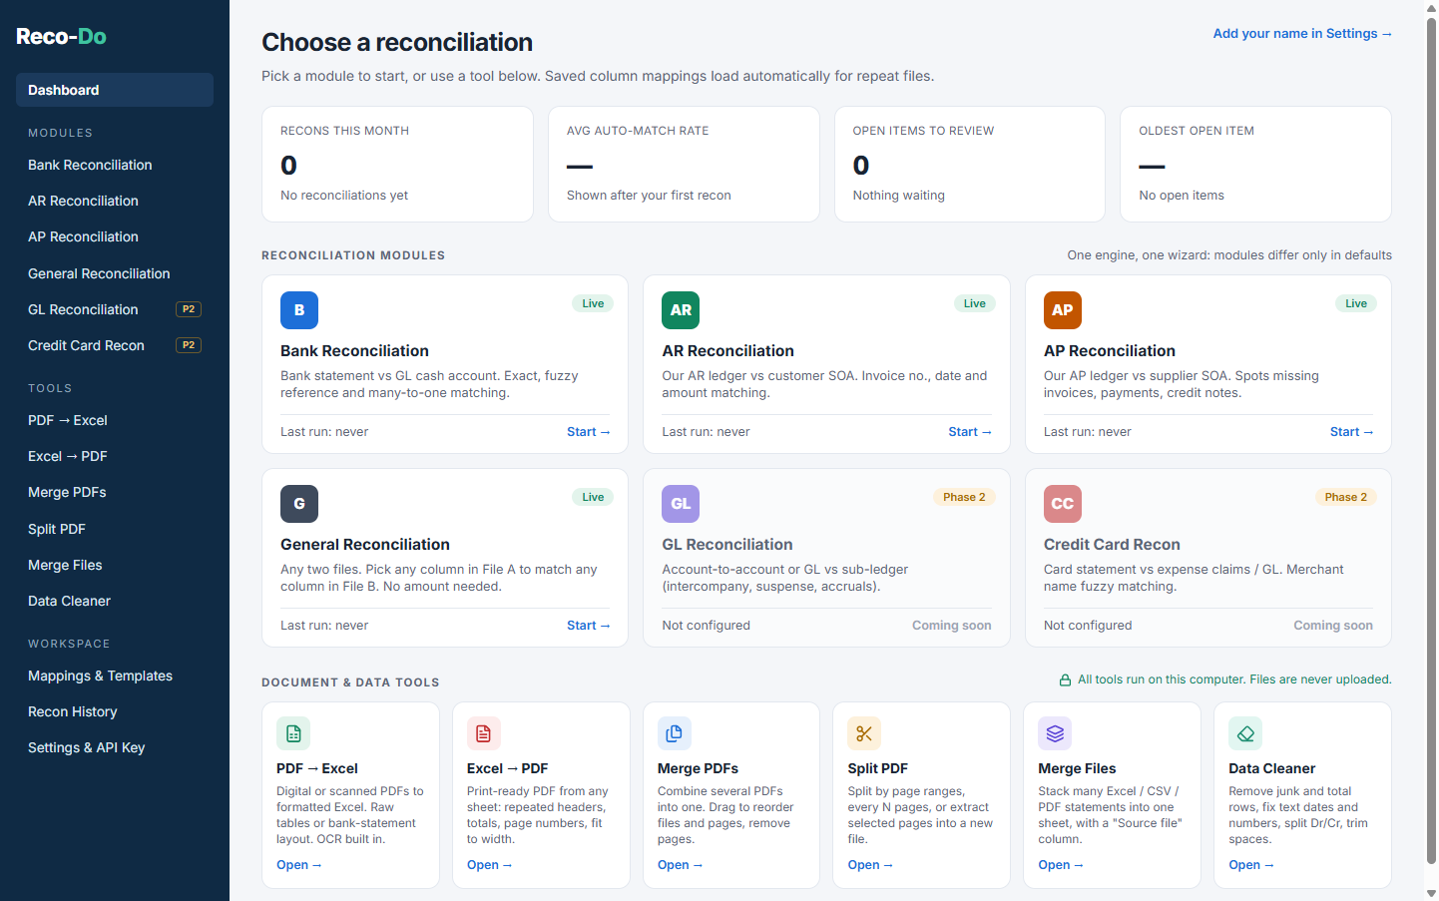
Figure 1. Reco-Do dashboard (screenshot of the application)
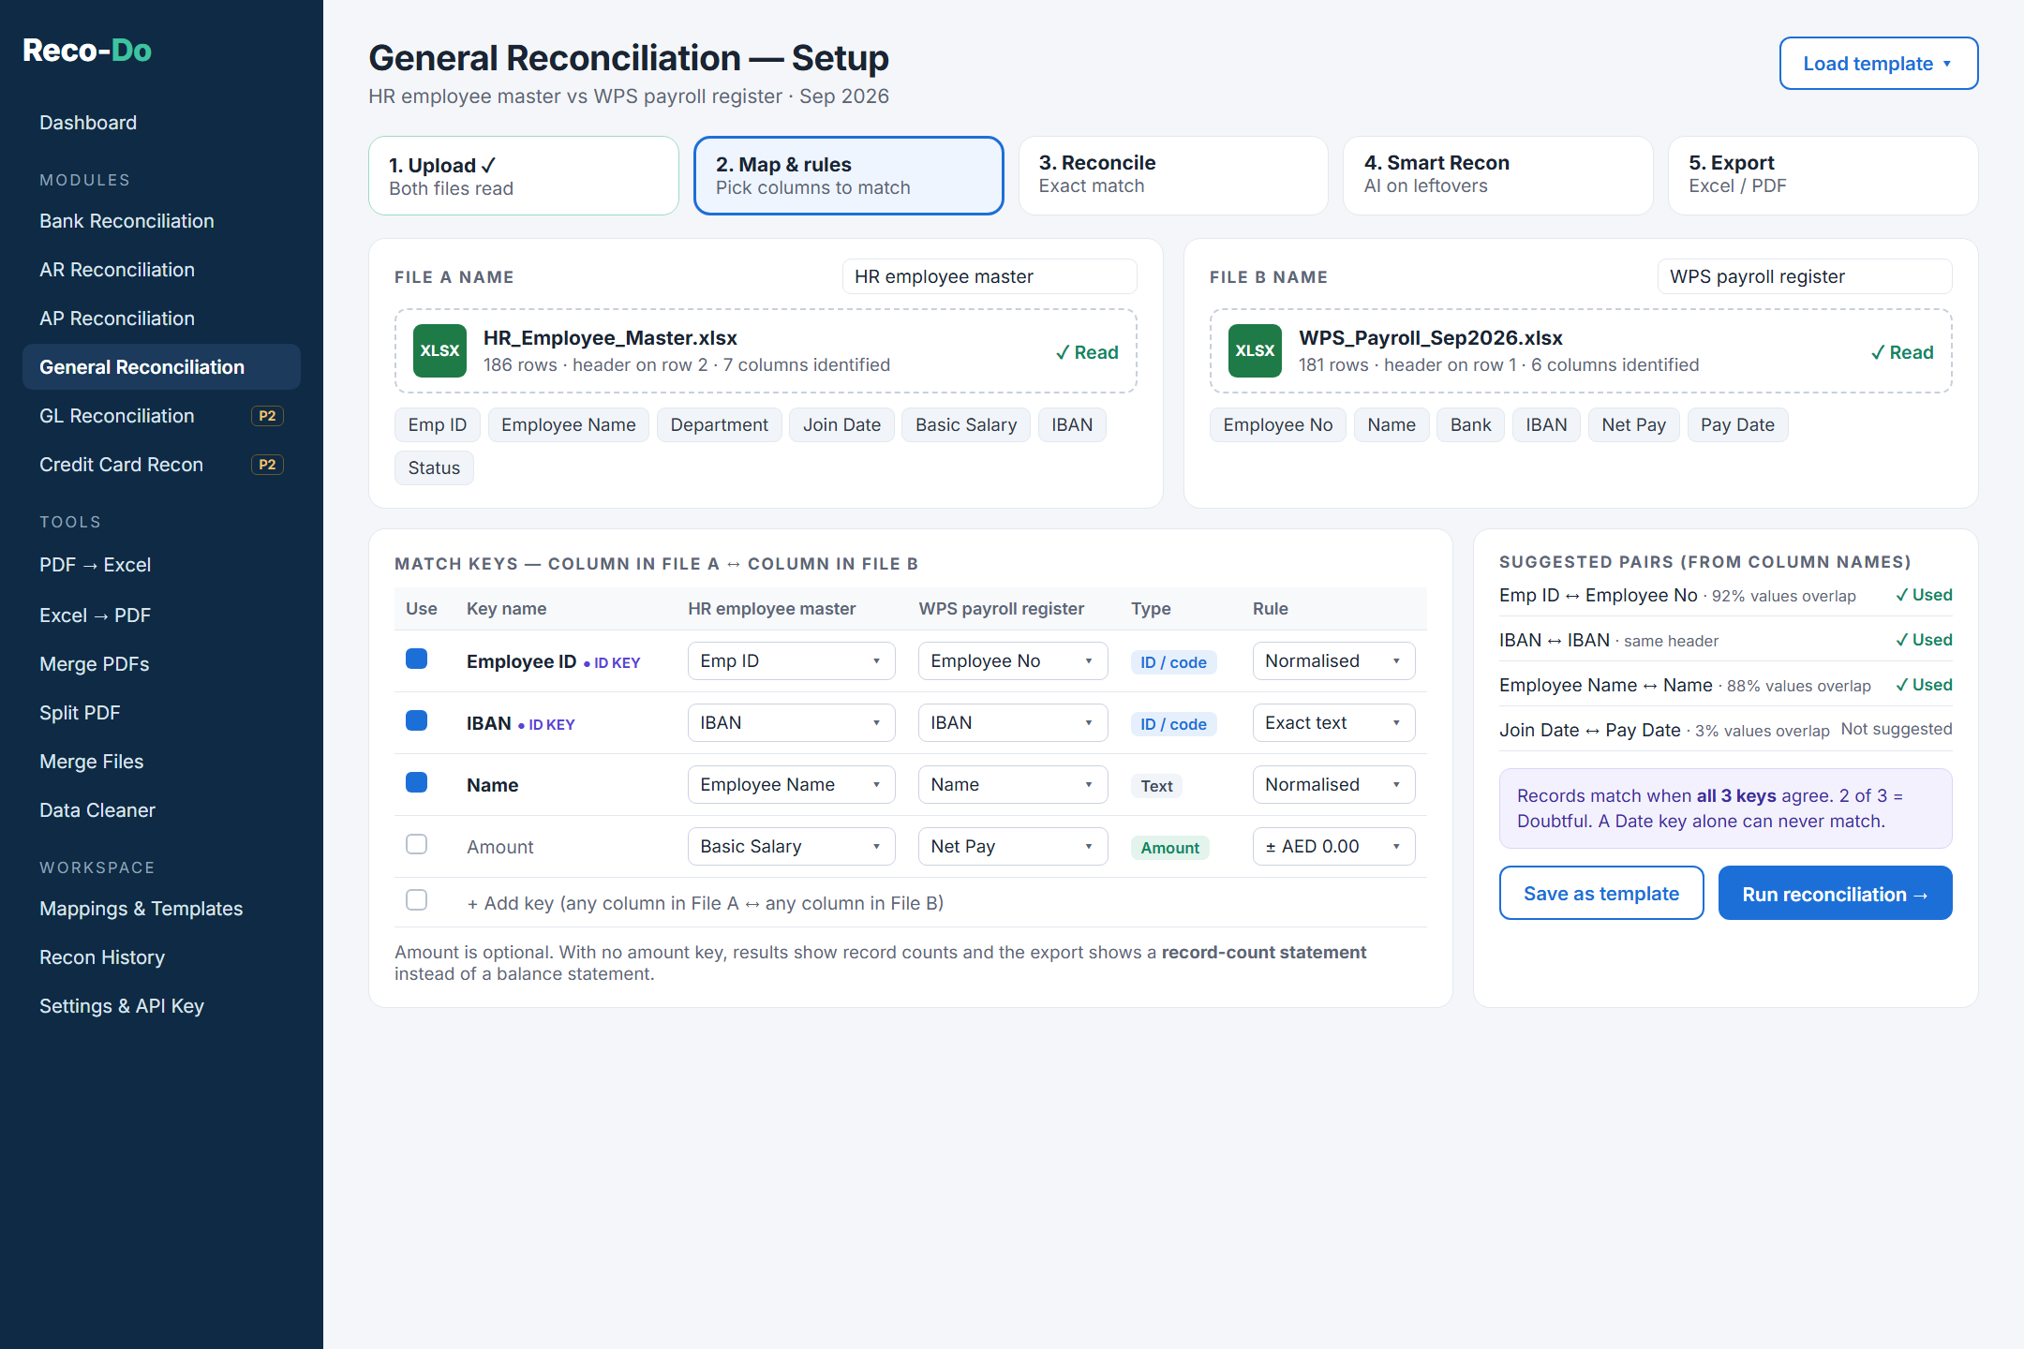
Figure 2. General Reconciliation setup: any column in file A matched to any column in file B (design mockup)
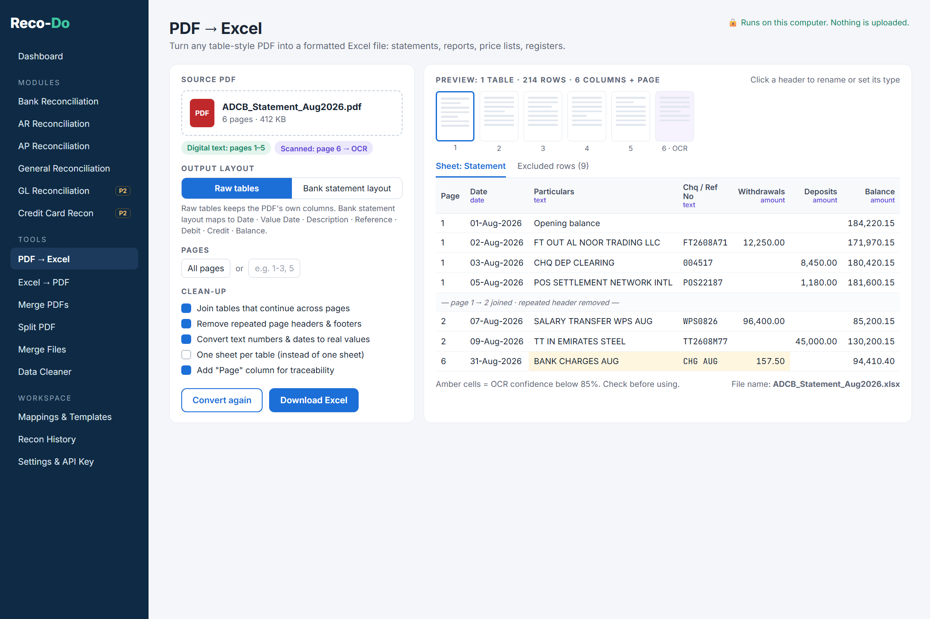
Figure 3. PDF → Excel tool (design mockup)

6. How Reco-Do addresses each problem
Problem | How Reco-Do solves it
Inconsistent formats, PDF statements | Automatic header detection, three amount layouts, PDF → Excel with OCR, Data Cleaner.
Opposite sign conventions | Same / inverse sign setting with sensible defaults per module and a live check.
Near-matches | Tolerances for dates, amounts and references; Doubtful and Likely tiers with reasons.
One-to-many items | Bounded combination search finds splits and groupings (up to 5 lines).
Duplicates | Never guessed: flagged as “Multiple identical candidates” for review.
No audit trail | Every decision logged with user, time, before/after and note; sign-off locks the reconciliation.
Data privacy | Desktop, offline, no server; AI optional with preview and approval.
Repetitive monthly set-up | Saved mappings, templates and recipes are reused automatically.

7. Technology
Electron (Windows desktop shell and installer), React and TypeScript (user interface), a pure TypeScript matching engine with automated tests, SheetJS and ExcelJS (reading and writing Excel), pdf.js, pdf-lib and jsPDF (PDF handling), Tesseract.js (on-device OCR), IndexedDB (local storage), and the Anthropic Claude API (optional Smart Recon).

8. Scope, roadmap and limitations
- This release: Bank, AR, AP and General reconciliation; Smart Recon; six document and data tools; sample files for every module with a one-click “Try with sample files” demo.
- Phase 2: GL Reconciliation and Credit Card Reconciliation, using the same engine and wizard.
- Known limitations: OCR accuracy depends on scan quality; very complex PDF layouts may need manual column adjustment; password-protected PDFs are not supported; the .exe is not code-signed, so Windows shows an “unknown publisher” warning on first run.

9. Conclusion
Reco-Do turns reconciliation from a manual spreadsheet exercise into a guided, explainable and auditable process. Routine matching is automated, the accountant’s attention goes to the items that really need judgement, and AI adds value on the hardest cases without taking control away from the professional or putting their data at risk.

